Virus Attack
Introduction:
A virus attack is a malicious attempt to compromise a computer system or network by infecting it with a virus, a type of malware that replicates itself and spreads to other systems, causing harm to the infected computer, network, or data. Virus attacks can occur through various means, including email attachments, infected software downloads, infected websites, and USB drives. Once a system is infected, the virus can cause a range of problems, including slow system performance, crashing or freezing, unusual network activity, pop-ups and ads, and data corruption. To prevent virus attacks, it is essential to install antivirus software, keep software up-to-date, use strong passwords, and practice safe computing habits. Despite these precautions, virus attacks can still occur, and it is crucial to have a plan in place for responding to and mitigating the effects of a virus attack.
How the Virus Spread:
1. Email Attachments: Opening malicious email attachments or clicking on links.
2. Infected Software Downloads: Downloading software from untrusted sources.
3. Infected Websites: Visiting websites that contain malicious code.
4. USB Drives: Inserting infected USB drives into a computer.
5. Network Vulnerabilities: Exploiting vulnerabilities in network protocols or software.
6. Social Engineering: Tricking users into installing malware or revealing sensitive information.
Execution of a Virus Attack
Step 1: Creating the Payload
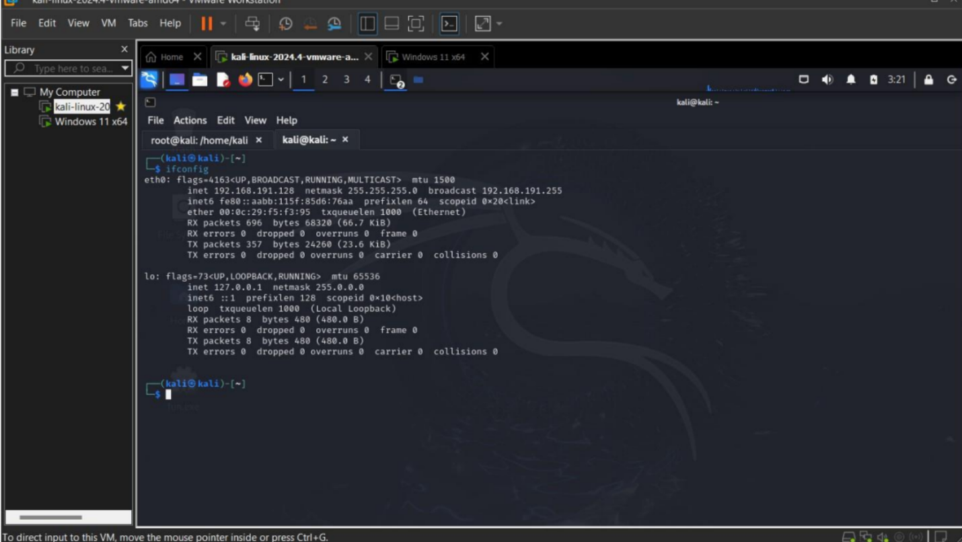
From this attack find the ip address
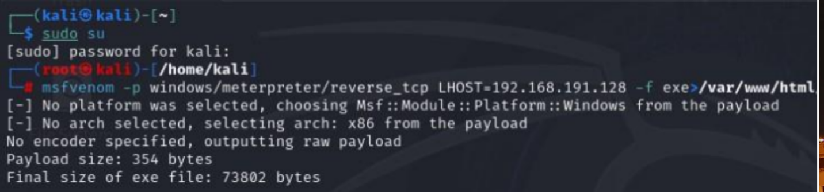
Step2: Deploying the Virus Attack
Deploying a virus refers to the process of releasing or spreading the virus into a computer system, network, or environment, allowing it to infect and replicate itself. This can be done through various means.
Step 3: Exploting the system
Exploiting a system refers to the process of taking advantage of vulnerabilities or weaknesses in a computer system, network, or application to gain unauthorized access, control, or data. 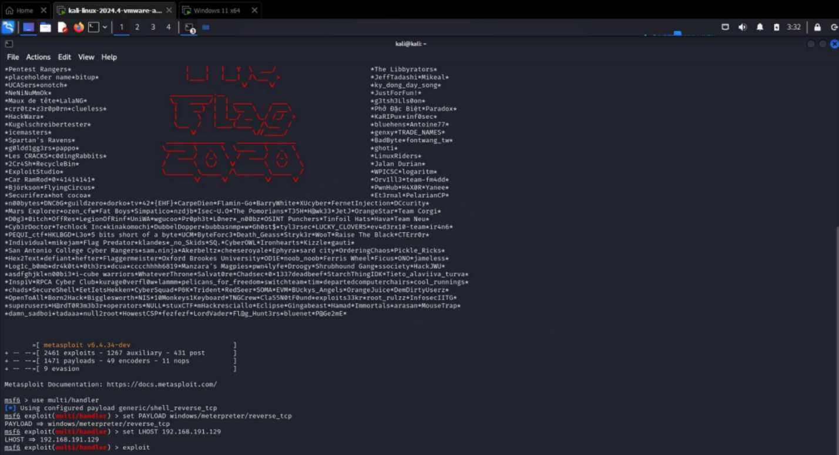
At this stage, the attacker can:
• Turn off security features to remain unnoticed.
• Steal sensitive files.
• Install key loggers to capture keystrokes.
• Delete or encrypt critical data for ransom.
Step 4: Concealing the Attack
To avoid detection, the attacker:
• Disables security features like Windows Defender and firewalls.
• Uses rootkits to hide the presence of the virus and maintain persistent access.

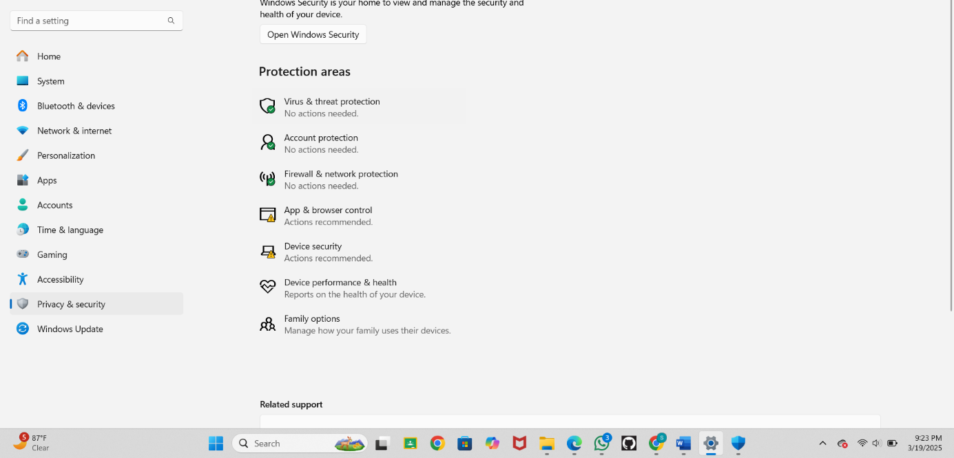
How to Prevent Virus Attacks:
1. Install Antivirus Software: Use reputable antivirus software that includes real-time protection, automatic updates, and scanning capabilities.
2. Keep Software Up-to-Date: Regularly update operating systems, browsers, plugins, and other software to patch security vulnerabilities.
3. Use Firewall Protection: Enable firewall protection to block unauthorized access to your computer or network.
5. Back Up Important Data Regularly: Backup copies on external hard drives and cloud storage. Employ encrypted backups for extra security.
6. Use Strong Passwords and Multi-Factor Authentication (MFA) : Create complex passwords with a mix of letters, numbers, and special characters. Enable MFA for an additional layer of security.
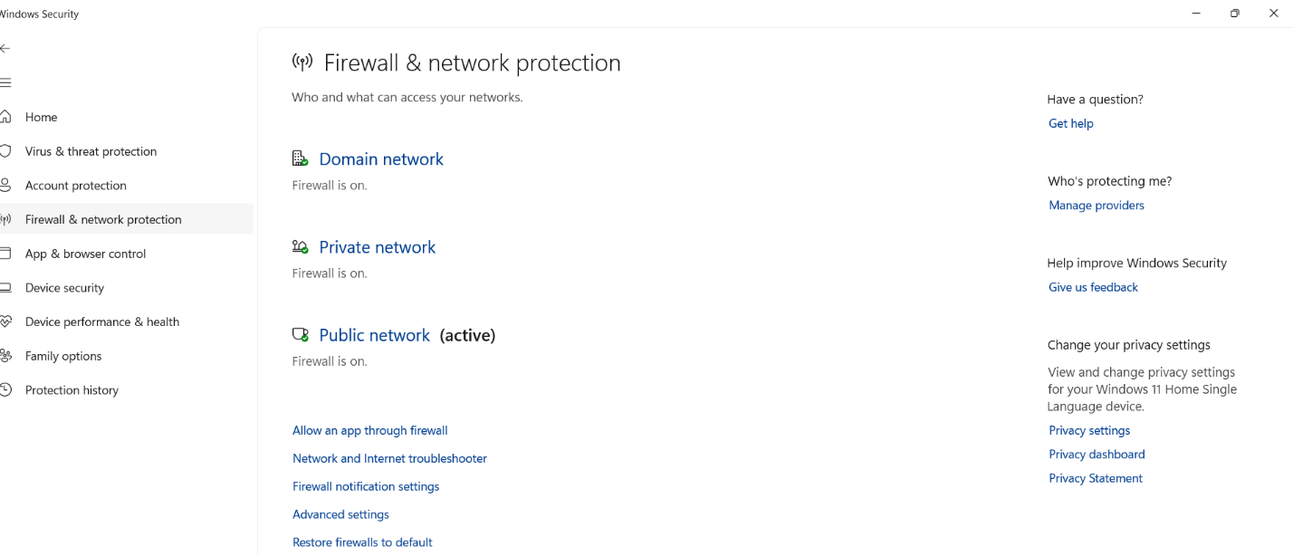
Conclusion: In conclusion, virus attacks pose a significant threat to computer systems, networks, and data, causing harm, disruption, and financial loss. These malicious software programs can spread quickly, exploiting vulnerabilities and weaknesses, and can be difficult to detect and remove. However, by understanding the types of virus attacks, their execution methods, and prevention strategies, individuals and organizations can take proactive measures to protect themselves. This includes installing antivirus software, keeping software up-to-date, using strong passwords, and practicing safe computing habits. By staying vigilant and taking a proactive approach to cybersecurity, we can reduce the risk of virus attacks and protect our digital assets.

Sanika Kadam
2124UCSF1112

